**Creating a Highly Available 3-Tier Architecture for Web Applications in AWS**

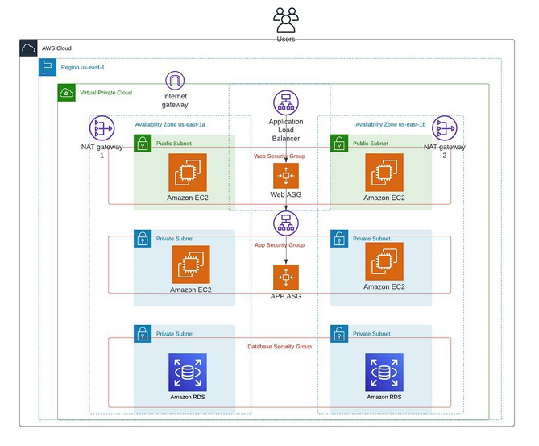

AWS provides a wide range of resources for developing and managing cloud applications, which can be customized to construct highly dependable and resilient cloud infrastructures. Suppose you are tasked with developing a three-tier architecture that is readily available for your organization’s new web application. This tutorial is extensive but comprehensive. You may want to bookmark this guide for future reference on creating web, application, and data tiers.

**What is a 3-Tier Architecture?**

A three-tier architecture comprises three layers, namely the presentation tier, the application tier, and the data tier. The presentation tier serves as the front-end, hosting the user interface, such as the website that users or clients interact with. The application tier, commonly referred to as the back-end, processes the data. Finally, the data tier is responsible for data storage and management.

* Create a VPC with 6 subnets of 2 public and 4 private subnets.

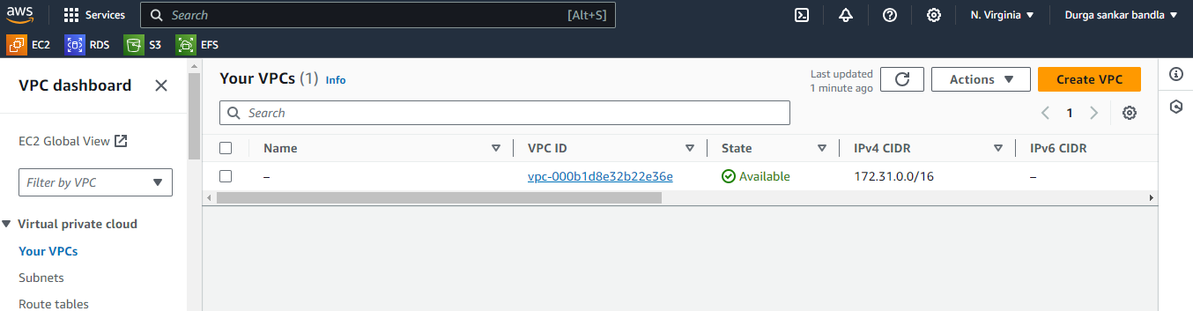

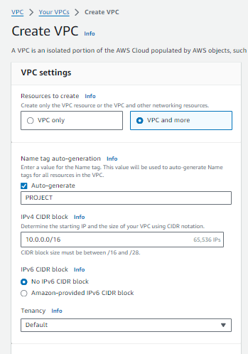

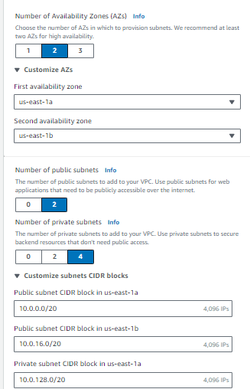

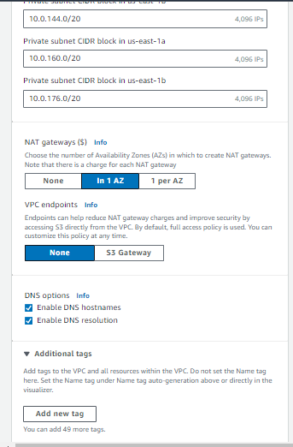

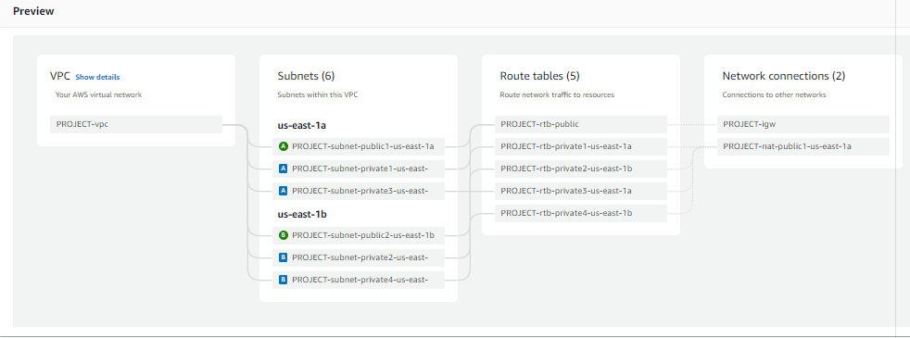

* When you click on the create vpc it will be created by the above preview.
* It will create 6 subnets.
* Consists of 2 public subnets.
* Consists of 4 private subnets.
* By the below work flow the vpc is created.

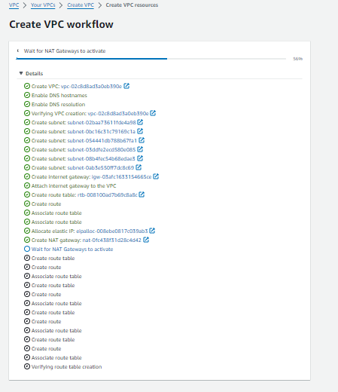

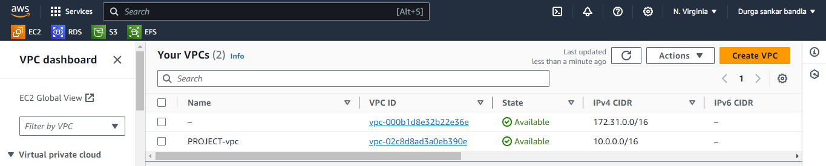

* Next click on the Subnets tab in the VPC console. Select one of the new subnets that was created, then under the “Actions” tab, expand the down arrow and select “Edit subnet settings.”
* Check “Enable auto-assign IPv4 address” and “Save.” We need to do this for all 6 new subnets that were created.

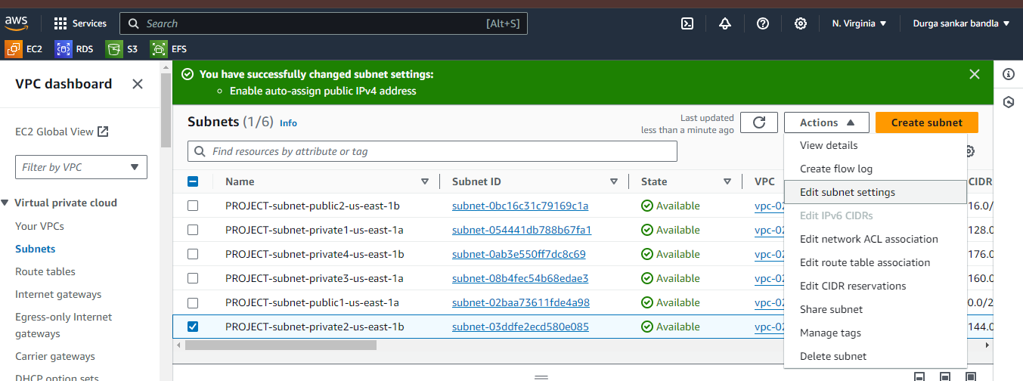

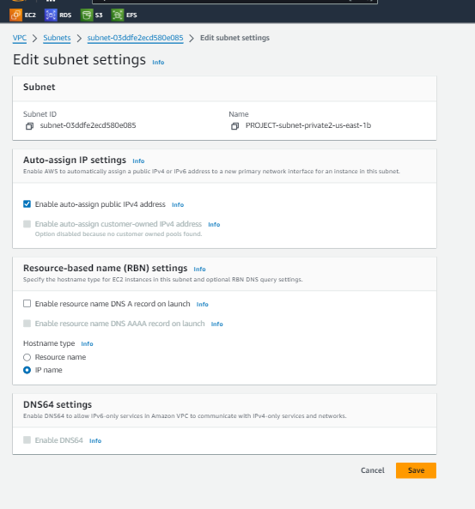

**Creating a Web Server Tier :**

* Go to EC2 dashboard and click on launch instanc.
* Give name tag as PROJECT-3TIER-PUBLIC1

->select ubuntu.

-> create key pair and named as PROJECT.

* Click on network settings

->select VPC as PROJECT.

->select subnet public1.

->Enable the Auto assign public IP.

->create security group name as 3TIER-SG.

->add http port number 80 for security group.

-> click on launch instance.

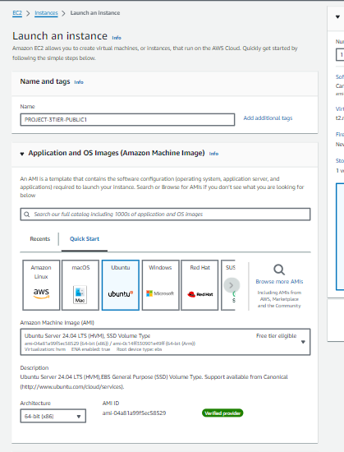

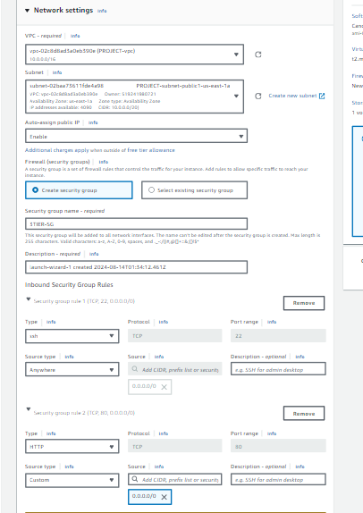

* By same create PROJECT-3TIER-PUBLIC2 select subnet public2.

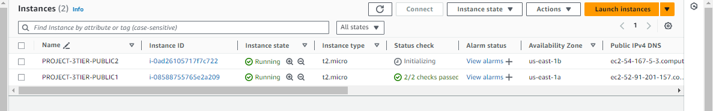

* Once created the instance click on connect and copy the ssh command in SSH client field and then go to git bash and connect to the server.
* Once connected change to root user->sudo -i.
* Then update the server->apt update -y.
* Install apache2->apt install apache2 -y.
* Change directory path->cd /var/www/html.
* Remove the default index.html and create new file.
* Restart->systemctl restart apache2.

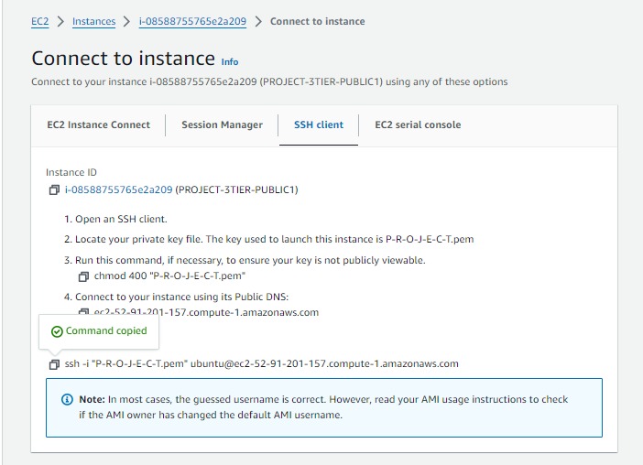

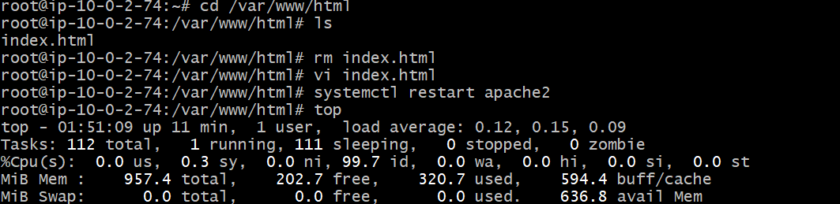

* By the same process connect to PROJECT-3TIER-PUBLIC2 and remove file and create new.

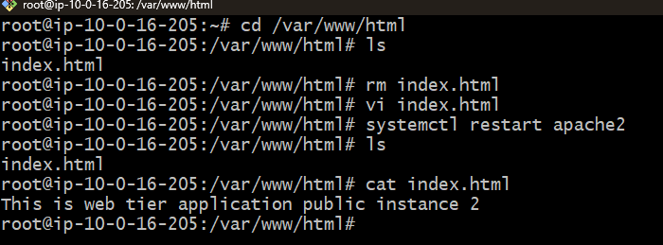

**Creating Load Balancer :**

* For load balancer first we need to create Target group.
* Click on create Target group

->select instances under choose target type.

->select VPC as PROJECT.

->select instances under register targets.

->click on include as pending below.

->click on create target group.

* Once target group created go to load balancer.
* Go to load balancer and click on create load balancer.
* Select application load balancer.
* Give name tag as WEB-TIER-LB

->click on internet facing under scheme field.

->select VPC PROJECT.

->select availability zone us-east-1a & us-east-1b.

->select subnets public1 & public2 .

>select security group.

->select target group WEB-TIER-TG).

->remaining fields leave as default and click on next.

->click on create load balancer.

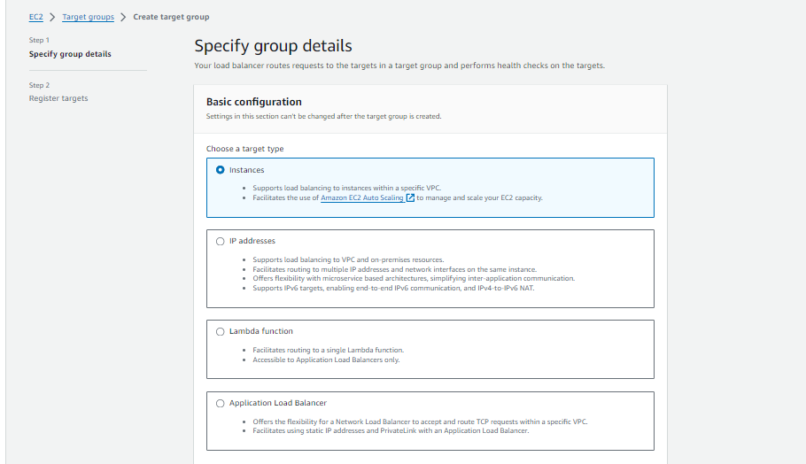

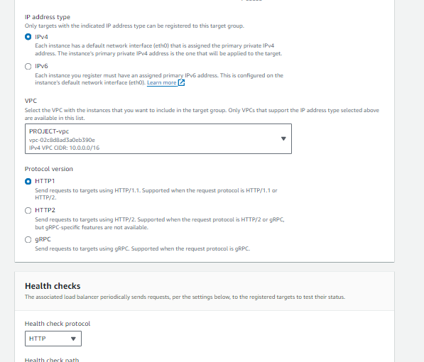

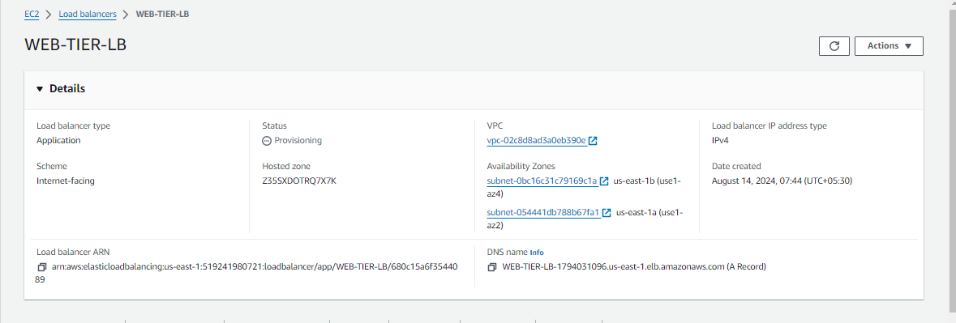

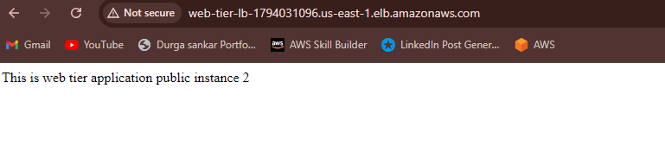

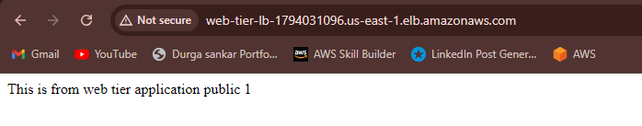

**Creating Auto Scalling :**

* Create image using instance

->select instance and click actions.

->image and templates.

->create image.

* Give name tag as WEB-TIER-IMG.

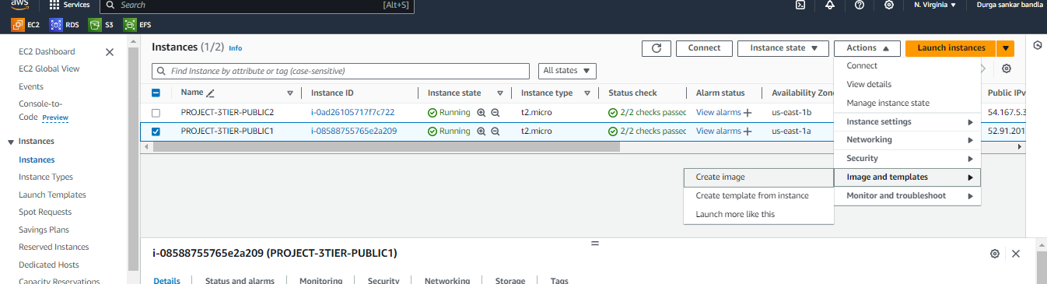

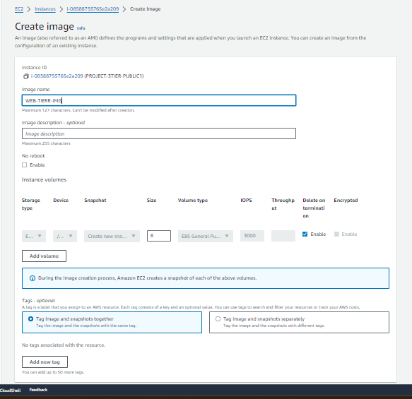

* Once image created go to EC2 dashboard and click on templates.
* Give name tag as WEB-TIER-TMT and ->template version as nothing.
* Click the network settings and select existing security group as shown in below.

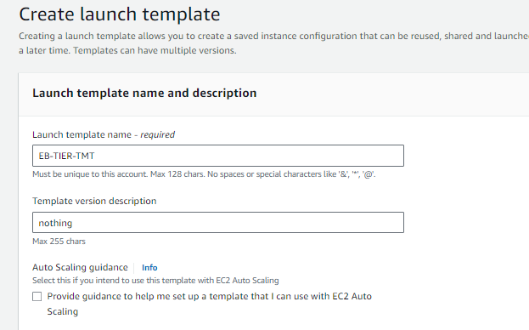

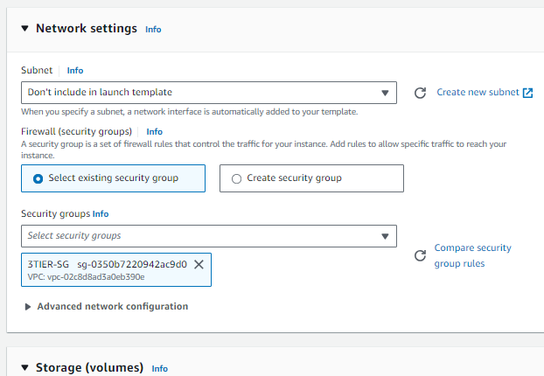

* Go to auto scaling and click on create auto scaling groups.
* Give name tag as WEB-TIER-AS
* Select created target group WEB-TIER-TG.
* Select the VPC

-> select availability zone us-east-1a (public1 subnet) & us-east-1b (public2 subnet)

->click attached to an existing load balancer

->select existing target group.

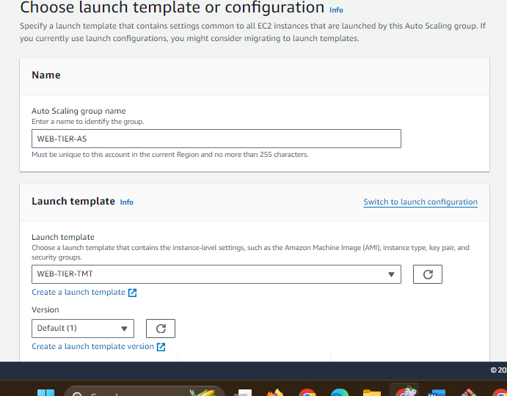

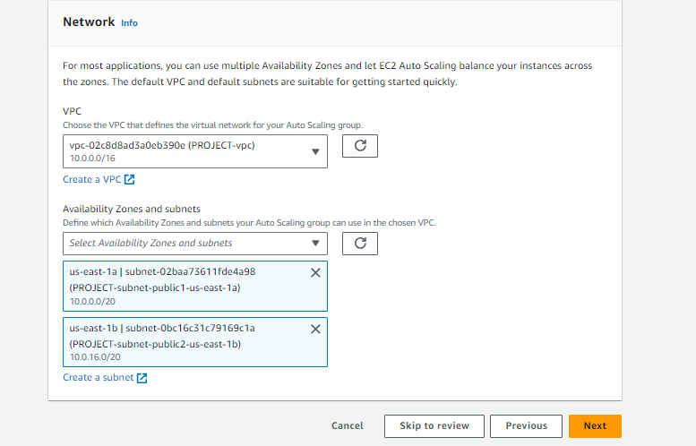

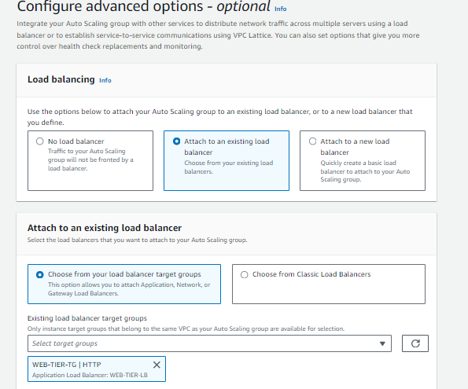

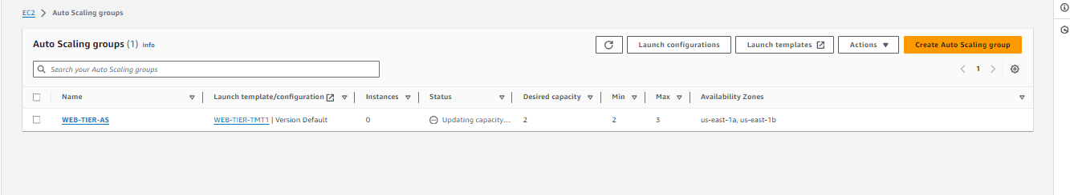

* After Auto Scalling 2 extra instances added. Previously 2 instances created and after auto scaling another 2 instances added to total 4 instances.

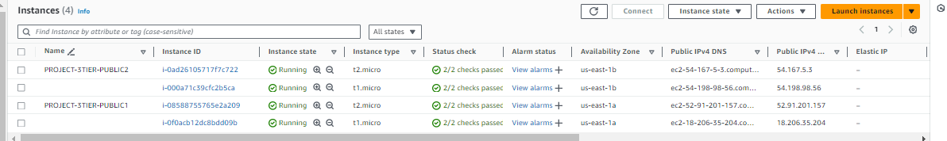

**Auto scaling for private subnets :**

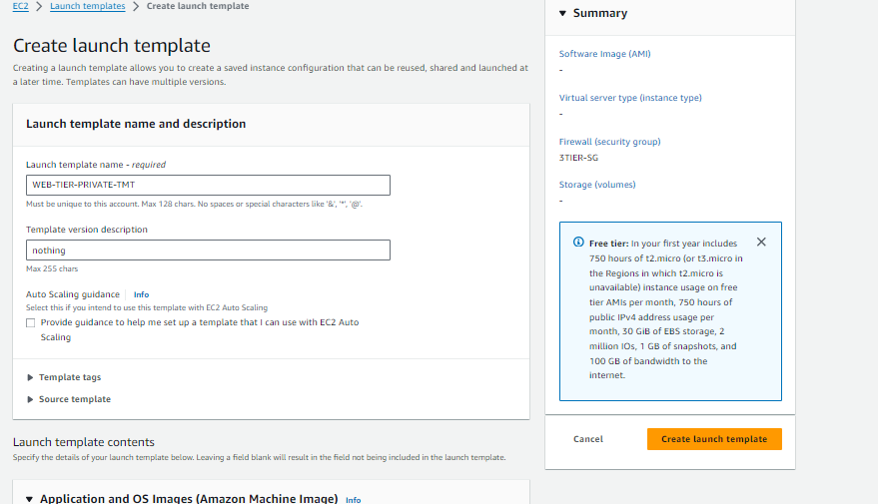

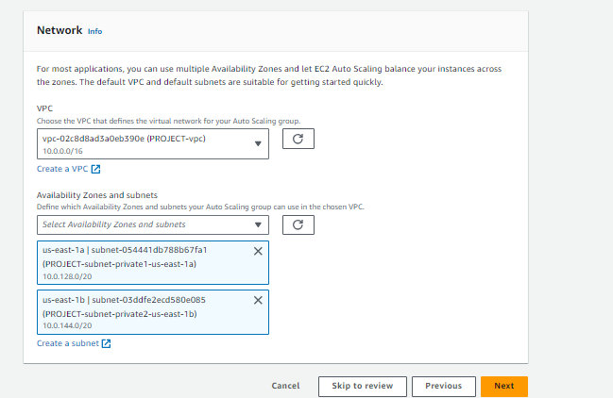

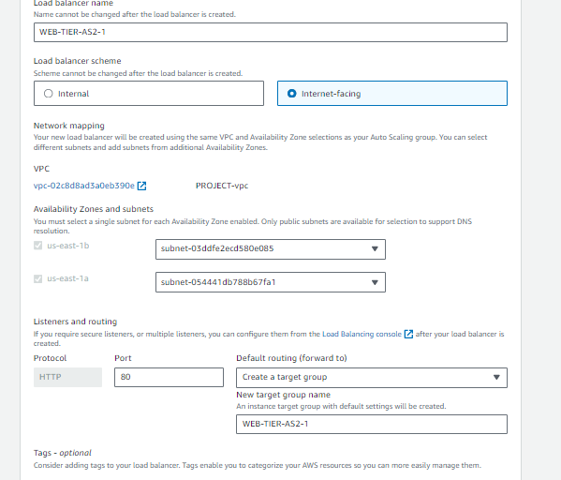

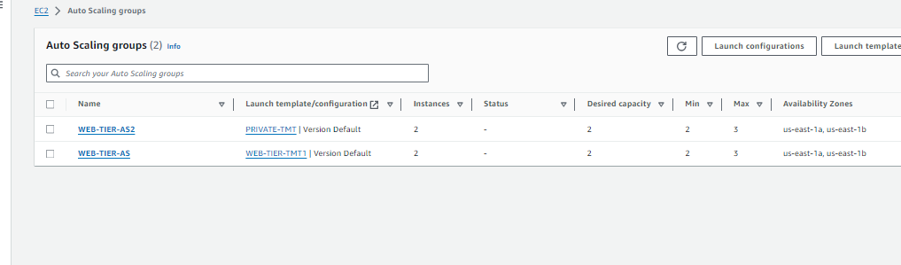

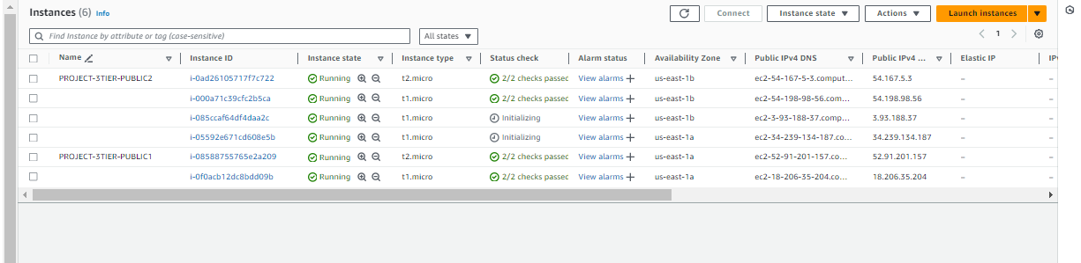

**Creating RDS :**

* Open RDS and search for subnet.
* Go to subnet group and click on create DB subnet group.
* Give name tag as my-3tier-project-db.
* Select VPC project-3tier and then click on create DB subnet.

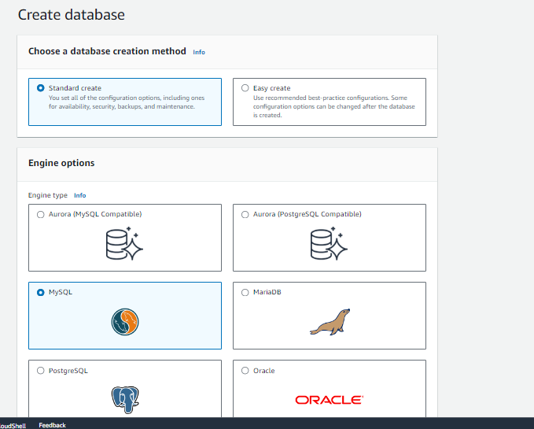

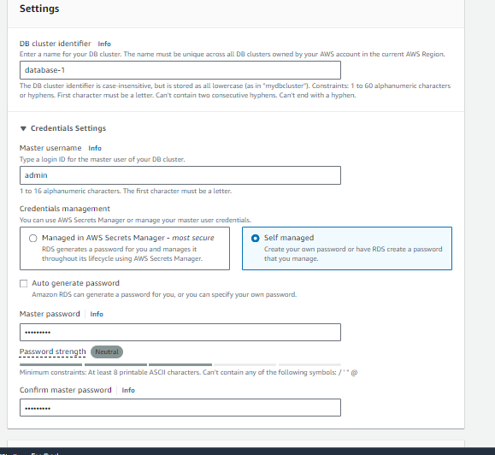

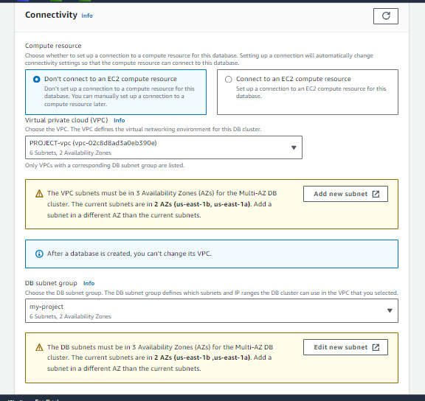

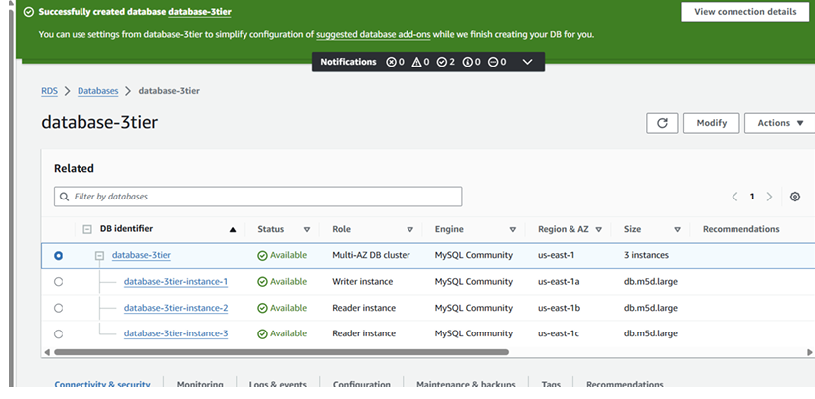

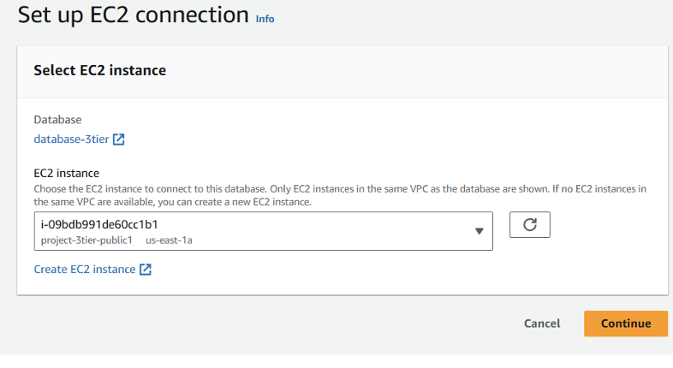

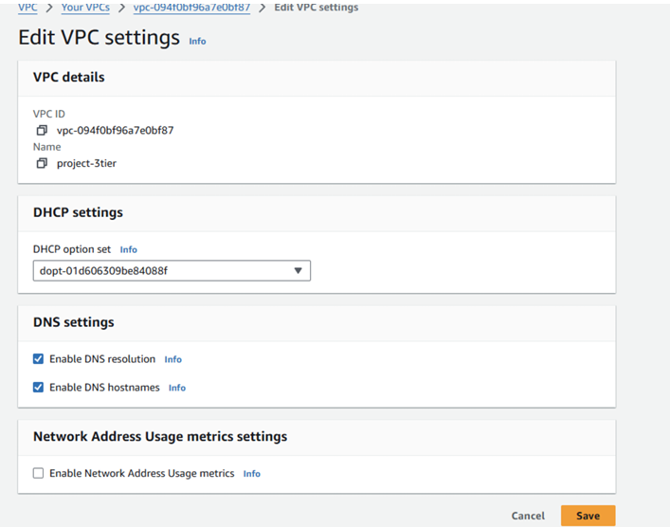

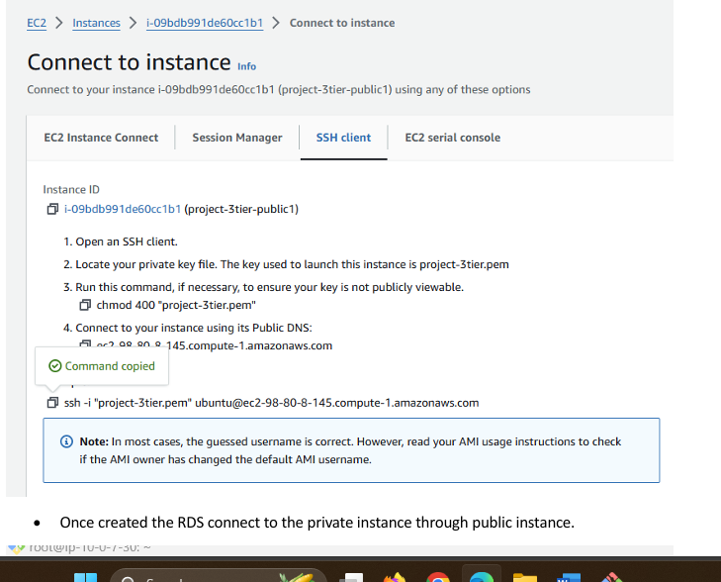

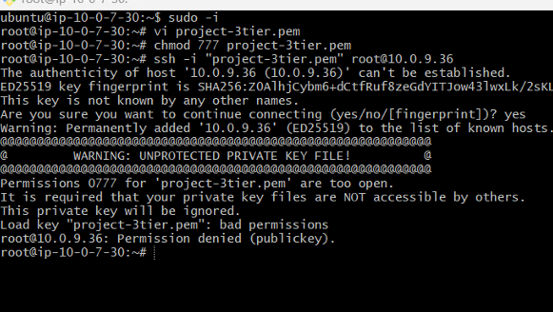

* Install MY SQL->sudo apt install mysql-server.
* Restart ->sudo systemctl start mysql service.
* Mysql -h database-3tier.cluster-c9emcoqi2lvz.us-east-1.rds.amazonaws.com(rds end point) u admin -p->Enter password-> u can connect to my SQL as shown in below.
* For creating table-> CREATE TABLE Persons ( ID int, LastName varchar(255), FirstName varchar(255), Age varchar(255) ).
* Create the table in in my sql.
* The output of creating table as shown in below.

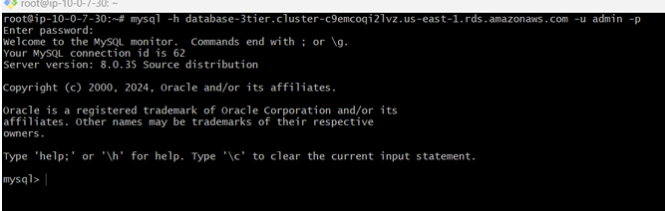

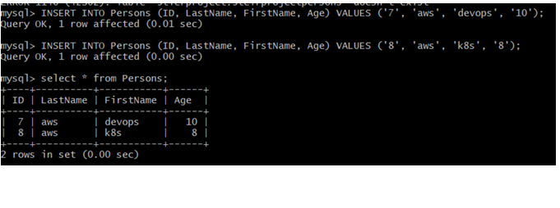**B.Durgasankar**

[**durgasankarbandla99@gmail.com**](mailto:durgasankarbandla99@gmail.com)